TABLE OF CONTENTS

S.NO | CHAPTER | PAGE NO
1. | Introduction
2. | Literature Survey
3. | Problem Statement
4. | Methodology
5. | Implementation
6. | Conclusion

TELCO PREDICTION OF CUSTOMER TURNOVER
ABSTRACT
Customer attrition or churn, is when customers stop doing business with a company. It can have a significant impact on a company's revenue and it's crucial for businesses to find out the reasons why customers are leaving and take steps to reduce the number of customers leaving. One way to do this is by identifying customer segments that are at risk of leaving, and implementing retention strategies to keep them. Also, by using data and machine learning techniques, companies can predict which customers are likely to leave in the future and take actions to keep them before they decide to leave. The dataset used in this study consists of Senior Citizen, Partner, Dependents, tenure, Phone Service, Multiple Lines, Internet Service, Online Security, Online Backup, Device Protection, Tech Support, Streaming TV, Streaming Movies, Contract, Paperless Billing, Payment Method, Monthly Charges, Total Charges, Churn status. Leveraging this dataset, we employ various machine learning algorithms to build a predictive model for customer churn. To address this classification problem, we compare the performance of multiple algorithms such as Logistic Regression, Decision Tree Classifier, Random Forest, Support Vector Classifier and KNN Classifier. Through thorough evaluation and comparison, we identify the most suitable algorithm that provides the highest accuracy and generalizability for customer churn prediction.
Keywords: Telecom churn, Logistic Regression, Decision Tree Classifier, Random Forest, Support Vector Classifier and KNN Classifier

I. INTRODUCTION

In developed nations, the telecommunications industry has proven to be one of the most important sectors of the economy. These service businesses struggle, especially because of customer churn, or the loss of valued clients to rivals. The level of opposition increased as a result of scientific advancement and the rise in operators. Businesses are working really hard and relying on intricate methods to thrive in this competitive industry. Customer churn results in a significant loss of telecom services and develops into a serious issue. To improve profitability, three major strategies have been introduced: attract new clients, upsell to existing ones, and lengthen client retention. However, a comparison of these tactics utilizing their respective return on investment (RoI) values has revealed that the third strategy is the most effective.
II. LITERATURE SURVEY

Hamdullah Karamollaoğlu et al [1]: The work in this paper is focusing on Machine learning techniques used in Customer Churn Prediction like Logistic Regression, K-Nearest Neighbor, Decision Trees, Random Forest, Support Vector Machines, AdaBoost, Multi-Layer Sensors, and Naive Bayes approaches were applied to the required datasets in the analytical process. The Random Forest method proved to be the most effective approach in the customer loss analysis carried out on both datasets.

Abhishek Gaur [2]: In this study, four machine learning models—Logistic Regression, SVM, Random Forest, and Gradient Boosted Tree—were trained. Of these, Gradient Boosting performed the best, while Logistic Regression and Random Forest were average and SVM was the least effective of the four.
Momin, S., Bohra, T. and Raut [3]: In order to predict customer turnover on IBM's Telco Customer turnover dataset, this chapter includes an experimental comparison of several conventional classification techniques, including K-nearest neighbors, naive Bayes, random forest, decision tree, and logistic regression, with artificial neural networks. Based on how well these models foresee client attrition, we have compared them. On validation data, our ANN model performs better than our performance of 79.86% for the conventional strategy of utilizing K-nearest neighbors, achieving an accuracy score of 82.83%. According to the results, multilayered ANN models that can learn on their own and accept tokenized data perform better than conventional classification methods.
Abhishek Gaur; Ratnesh Dubey [4]: The focus of this work is on different machine learning methods for predicting customer churn. Using these methods, classification models may be built using techniques like Logistic Regression, SVM, Random Forest, and Gradient Boosted Tree.
T. Vafeiadis et al [5]: These results show that the boosted versions of the models are clearly superior to the ordinary (non-boosted) counterparts. The SVM-POLY employing AdaBoost was the best overall classifier, with an F-measure of over 84% and accuracy of approximately 97%.
Fan, J., Zhang, J.et al [6]: These results show that the boosted versions of the models are clearly superior to the ordinary (non-boosted) counterparts. The SVM-POLY employing AdaBoost was the best overall classifier, with an F-measure of over 84% and accuracy of approximately 97%.
Aayushi Gandhi[7]: In order to forecast telecom customer turnover, machine learning and deep learning techniques are investigated in this study. To predict whether a client will leave or stay, widely used methods like Random Forest Classifiers and SVMs are contrasted with somewhat more recent structures like XGBoost and Deep Neural networks. By running these models via a grid search, the effectiveness of the models is further investigated. From this experiment, it can be concluded that the Random Forest model, which has a prediction accuracy of 90.96% on the testing data prior to grid search, performs the best for this specific use case.
III. PROBLEM STATEMENT

"In today's fiercely competitive telecommunications industry, retaining customers and reducing churn rates are paramount for telecom service providers. Customer churn, defined as the phenomenon where customers choose to terminate their subscriptions and leave the telecom industry altogether, poses a significant challenge. Telecom companies face the risk of not only losing revenue from departing customers but also struggling to sustain growth and profitability. The primary problem to be addressed in this project is the prediction of customer churn within the telecom industry. Specifically, the objective is to develop accurate and actionable predictive models that can identify customers at risk of leaving the telecom industry. By doing so, telecom companies can take proactive measures to retain these customers, enhance their overall experience, and, ultimately, mitigate the adverse effects of industry attrition.
This project entails the following key challenges:
Data Collection and Integration: Collecting and integrating diverse datasets, including customer profiles, billing records, service subscriptions, usage patterns, customer service interactions, and historical churn data, to create a comprehensive dataset for analysis.
Feature Engineering: Identifying and engineering relevant features that capture the underlying factors contributing to customer churn within the telecom industry. These features may include customer demographics, contract details, service quality metrics, billing history, and customer engagement data.
Model Development: Building robust machine learning models capable of predicting customer churn accurately. These models should take into account the dynamic nature of customer behavior and incorporate temporal aspects that influence churn decisions.
Model Interpretability: Ensuring that the predictive models provide insights into why certain customers are more likely to leave the telecom industry. Interpretability is crucial for devising targeted retention strategies.
Model Deployment: Implementing the predictive models in a production environment where they can continuously monitor and provide real-time predictions about customer churn. This enables telecom companies to take timely actions to retain customers.

IV. METHODOLOGY

4.1 Data Set
The data set is the foundation for everything, and it must contain complete facts to enable the machine to learn about the issue. Datasets can be created or constructed using the discarded information found online. Some challenges include building a dataset that makes sense and provides guidance on how to respond based on the problem's real-time inputs. Every day, data can be acquired via the internet. Data are gathered into datasets. A data set typically consists of a single database table or statistical data matrix, where each row corresponds to a specific member of the data set in question and each column defines a specific variable. Values are listed in the data set.

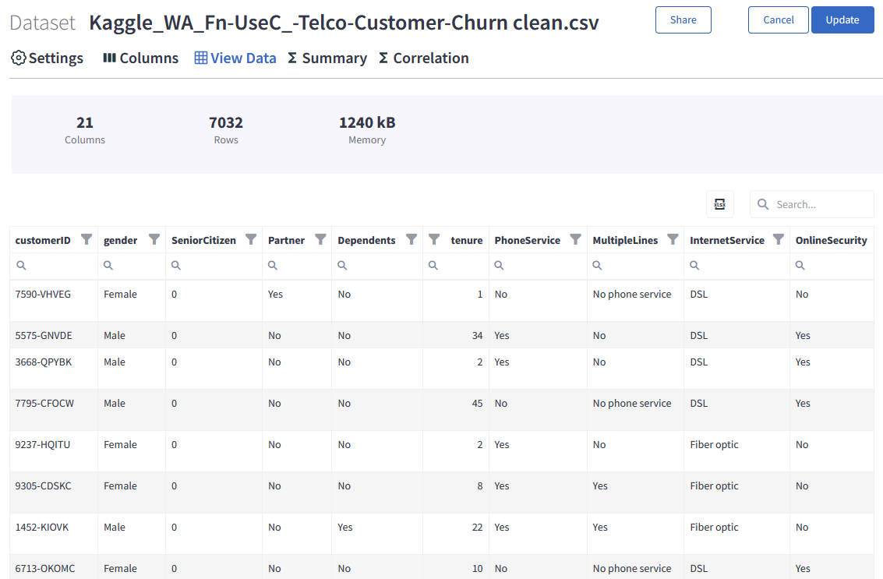

4.2 Data Collection:
Gather historical customer data from your telecom database, including customer demographics, usage patterns, contract details, billing information, customer service interactions, and any other relevant information.
Ensure the dataset includes both churned (customers who left) and retained (customers who stayed) records for model training.
4.3 Data Cleaning:
Start

Missing values?

Yes
Not
Imputation detection

Outliers detection

Remove duplicate instances

Dimensionality reduction

End

Handling Missing Data: Identify and address missing values. Options include removing rows with missing values, imputing missing values using appropriate methods, or flagging missing values for further consideration.
Handling Duplicates: Check for and remove duplicate records to maintain data integrity.
Outlier Detection and Treatment: Identify outliers in numerical features and decide whether to cap/extreme value replacement or remove extreme values.
Handling Categorical Variables: Encode categorical variables using techniques like one-hot encoding or label encoding.
Normalization/Standardization: Normalize or standardize numerical features to ensure consistent scales.
Balancing Imbalanced Data: If there's a class imbalance between churned and retained customers, consider oversampling the minority class or under sampling the majority class to balance the dataset.
Feature Engineering: Create new features or modify existing ones to capture meaningful information for churn prediction. This could include calculating customer tenure, deriving usage trends, or creating aggregate statistics.
Validation of Data Consistency: Ensure data consistency and accuracy by validating against business rules and common-sense logic.
Handling Anomalies: Detect and address anomalies or data entry errors that may affect the quality of the dataset.
Data Transformation: Apply appropriate transformations to the data, such as logarithmic transformations, to make it suitable for modeling.

4.4 Data Preprocessing:
Feature Selection: Select the most relevant features for churn prediction based on domain knowledge and feature importance analysis.
Data Splitting: Divide the dataset into training, validation, and test sets. A typical split may be 70% for training, 15% for validation, and 15% for testing.
Scaling Features: Normalize or standardize features as required, particularly for algorithms sensitive to feature scales.
Handling Time-Series Data: If time-series data is available, consider time-based features and data splitting strategies that preserve chronological order.

4.5 Data Exploration:
Data exploration is the crucial first step in understanding the dataset and gaining insights into the factors that influence customer churn. This phase involves examining the data from different angles to identify patterns and relationships.
Univariate Analysis:
Summary Statistics: Compute descriptive statistics such as mean, median, mode, standard deviation, and range for numerical features. Calculate frequency counts for categorical features.
Data Distributions: Visualize data distributions using histograms, box plots, and density plots for numerical features. For categorical features, create bar charts to show the distribution of categories.
Identify Outliers: Detect outliers in numerical features using statistical methods or visualizations. Determine whether outliers are genuine data points or errors that need to be addressed.
Feature Importance: Assess the importance of individual features in relation to the target variable (churn). This can be done through techniques like correlation analysis or feature importance scores from machine learning algorithms.
Bivariate Analysis:
Bivariate analysis explores the relationships between pairs of variables to understand how they interact and affect each other. In the context of telco customer churn prediction, this helps identify which features may have a significant impact on churn.
Correlation Analysis: Calculate correlation coefficients (e.g., Pearson, Spearman) between numerical features and the target variable (churn). Identify features with strong positive or negative correlations.
Visualizations: Create visualizations like scatter plots for numerical features against churn and stacked bar charts or heatmaps for categorical features against churn. These visualizations can reveal trends and dependencies.
Hypothesis Testing: Perform statistical tests (e.g., chi-squared test for categorical variables) to determine if there are statistically significant differences in churn rates among different categories or groups within features.

V. IMPLEMENTATION
VI. CONCLUSION

REFERENCE
[1] V. Lazarov and M. Capota, ‘‘Churn prediction,’’ Bus. Anal. Course, TUM Comput. Sci, Technische Univ. München, Tech. Rep., 2007. [Online]. Available: http://citeseerx.ist.psu.edu/viewdoc/download? doi=10.1.1.462.7201&rep=rep1&type=pdf.
[2] S. A. Qureshi, A. S. Rehman, A. M. Qamar, A. Kamal, and A. Rehman, ‘‘Telecommunication subscribers’ churn prediction model using machine learning,’’ in Proc. 8th Int. Conf. Digit. Inf. Manage., Sep. 2013, pp. 131–136
[3] F. Castanedo, Using Deep Learning to Predict Customer Churn in a Mobile Telecommunication Network (2014)
[4] J. Hadden, A. Tiwari, R. Roy, D. Ruta, Computer assisted customer churn management: state-of-the-art and future trends. Comput. Oper. Res. 34, 2902–2917 (2007). https://doi.org/10.1016/j.cor.2005.11.007
[5] C. Kirui, L. Hong, W. Cheruiyot, H. Kirui, Predicting customer churn in mobile telephony industry using probabilistic classifiers in data mining. Int. J. Comput. Sci. Issues. 10, 165–172 (2013)
[6] S.A. Qureshi, A.S. Rehman, A.M. Qamar, A. Kamal, A. Rehman, Telecommunication subscribers’ churn prediction model using machine learning, in: 2013 Eighth International Conference on Digital Information Management (ICDIM), IEEE, 2013, pp. 131–136.
[7] Adhikary, D.D., & Gupta, D. (2021). Applying over 100 classifiers for churn prediction in telecom companies. Multimedia Tools and Applications, 80 (28), 35,123–35,144. https://doi.org/10.1007/s11042-020-09658-z.
[8] "How Costly Is Customer Churn in the Telecom Industry?", The European Business Review, Aug 2020, [online] Available: https://www.europeanbusinessreview.com/how-costly-is-customer-churn-in-the-telecom-industry/.

